**TEAM-B**

S. Krushitha

K. Kavya

M. Charan Sai

Vipul

G. Dinesh

**Step-1** Installing SonarQube and Nexus Server

1. Install Java using “yum install”.

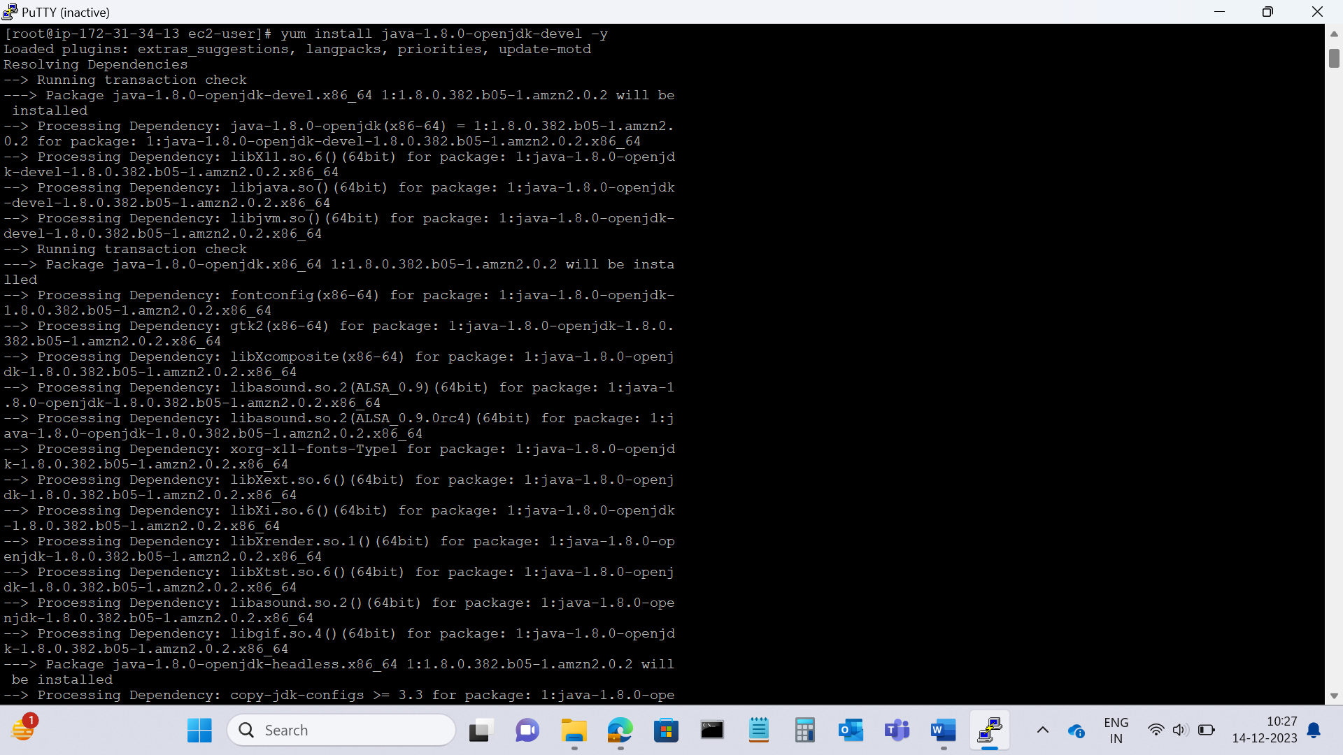

1. Download SonarQube and Nexus server using “wget”.

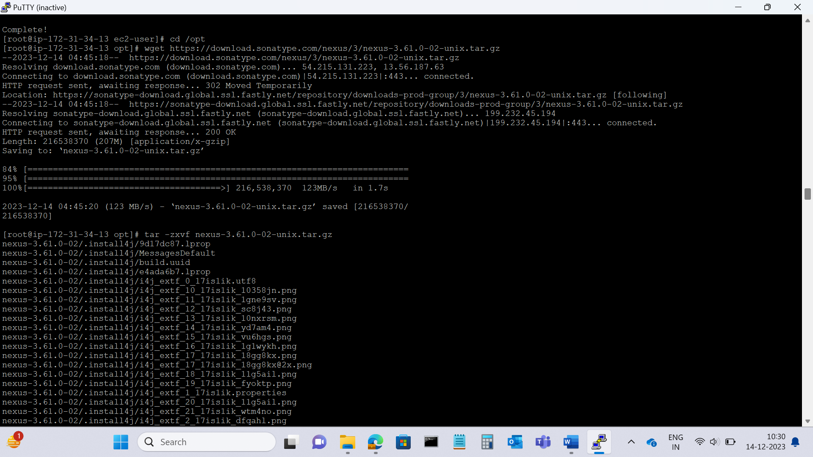

1. Unzip the downloaded tar file.
2. Add user.
3. Give sudo access to the user.
4. Change the owner and group permissions.
5. Creating Server as a service
6. Enable the service.
7. Start the service.
8. Access the nexus server using IP address:8081 in the browser.
9. Create two nexus repositories

* Snapshot repository
* Release repository

**Step-2** Login to the Jenkins

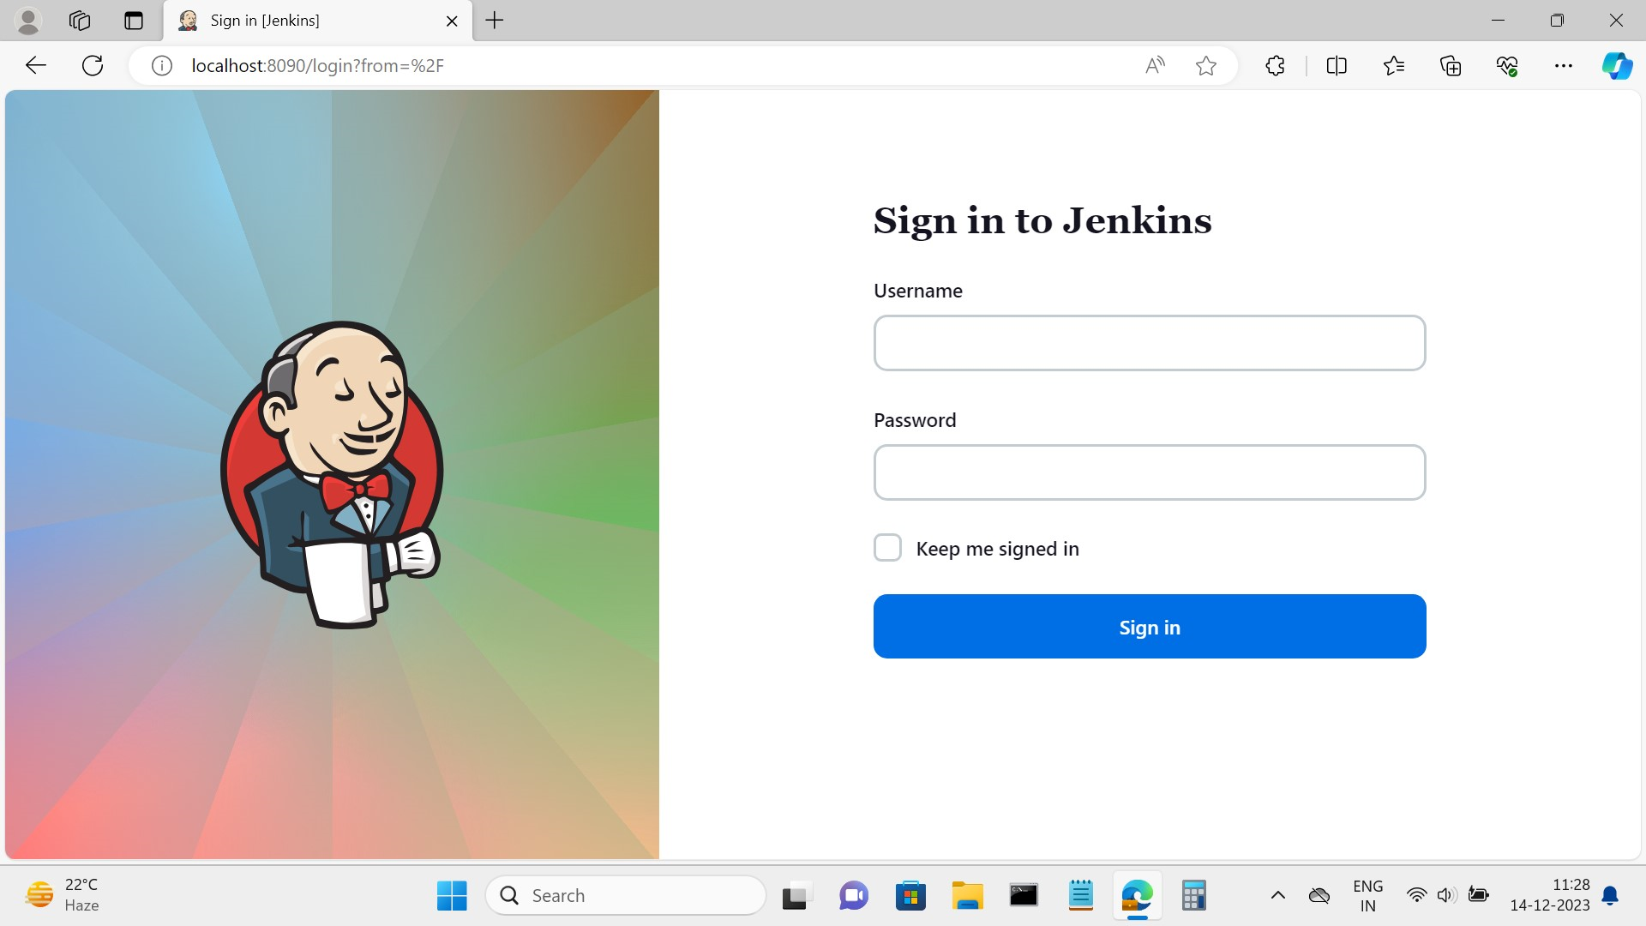

**Step-2** Click on the **New item** at the left top.

**Step-3** In the **Enter an item name** field, specify the name for your new Pipeline project.

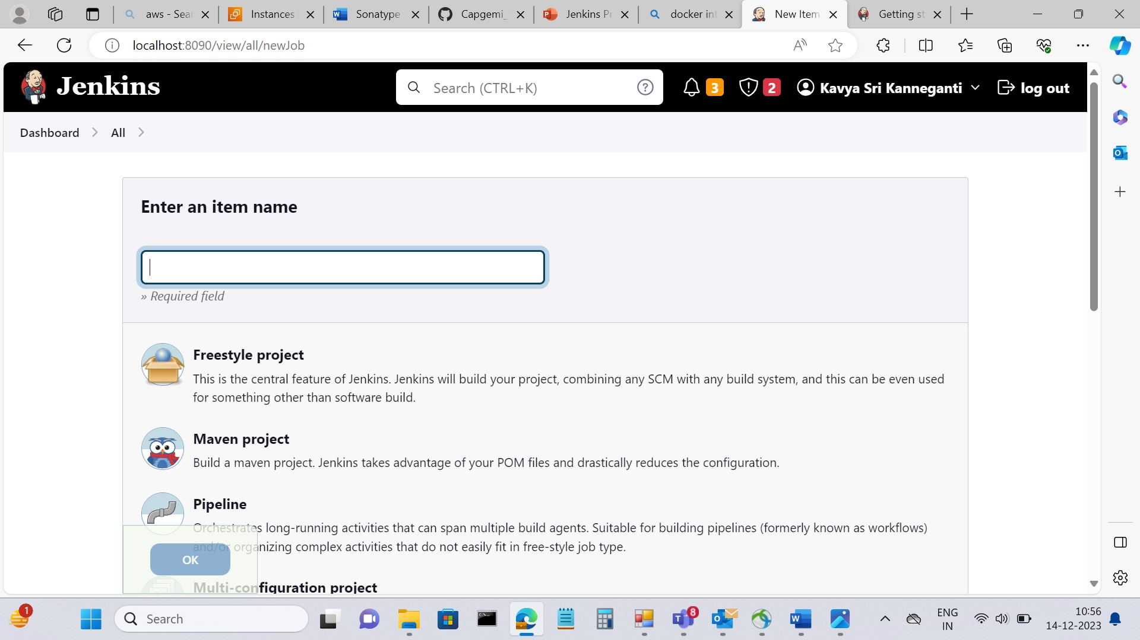

**Step-4** Scroll down and select the  **Maven** **Project**, then click **OK** at the end of the page to open the configuration page.

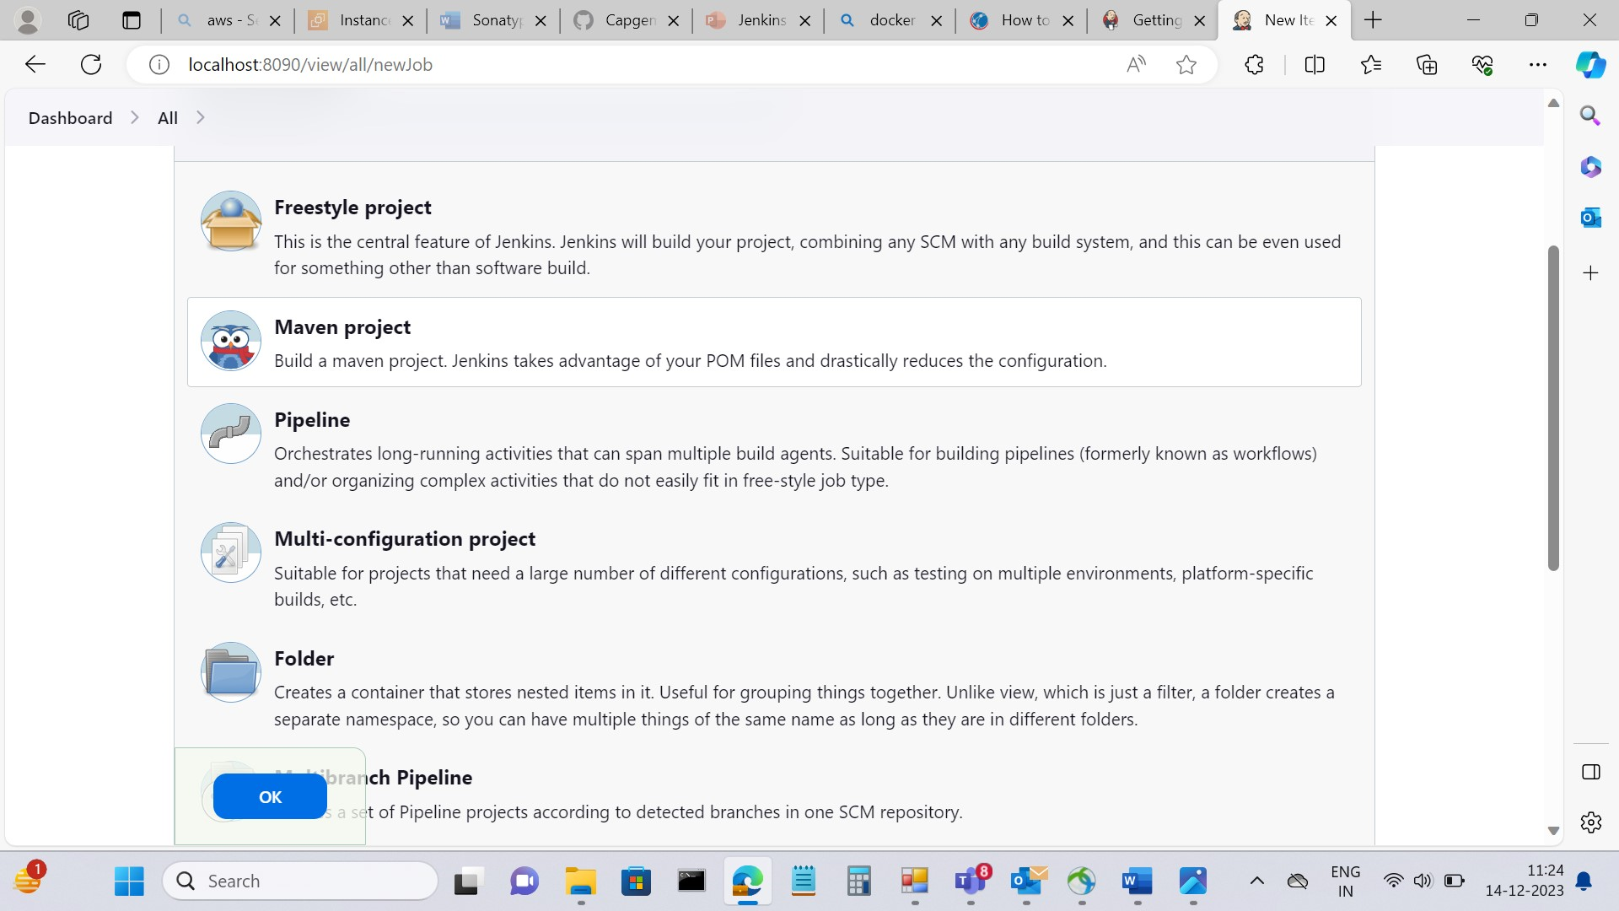

**Step-5** Now Configure the pipeline according to the project.

* In Source Code Management paste the git repository link for Maven Web Application
* Link: <https://github.com/Kavyasri25/maven-web-application.git>

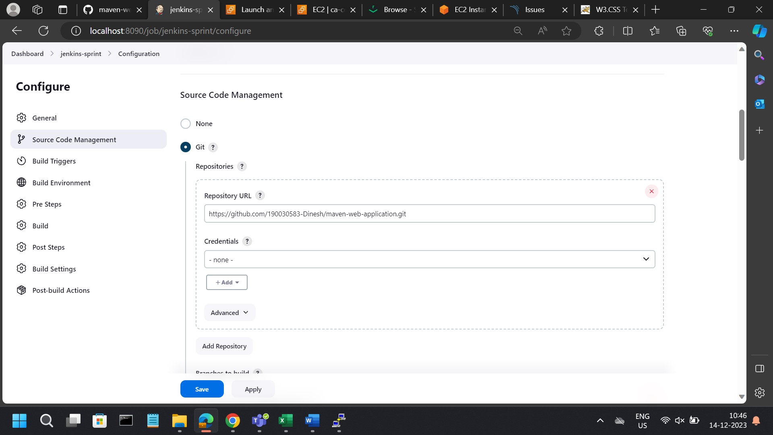

* In Build Triggers schedule the time

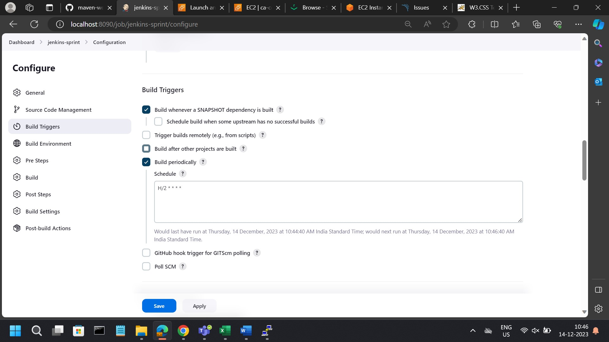

* In Build steps paste the path of the pom.xml file and goal “clean deploy sonar:sonar”
* Add SonarQube server details and nexus server details in distribution management tab inside pom.xml file

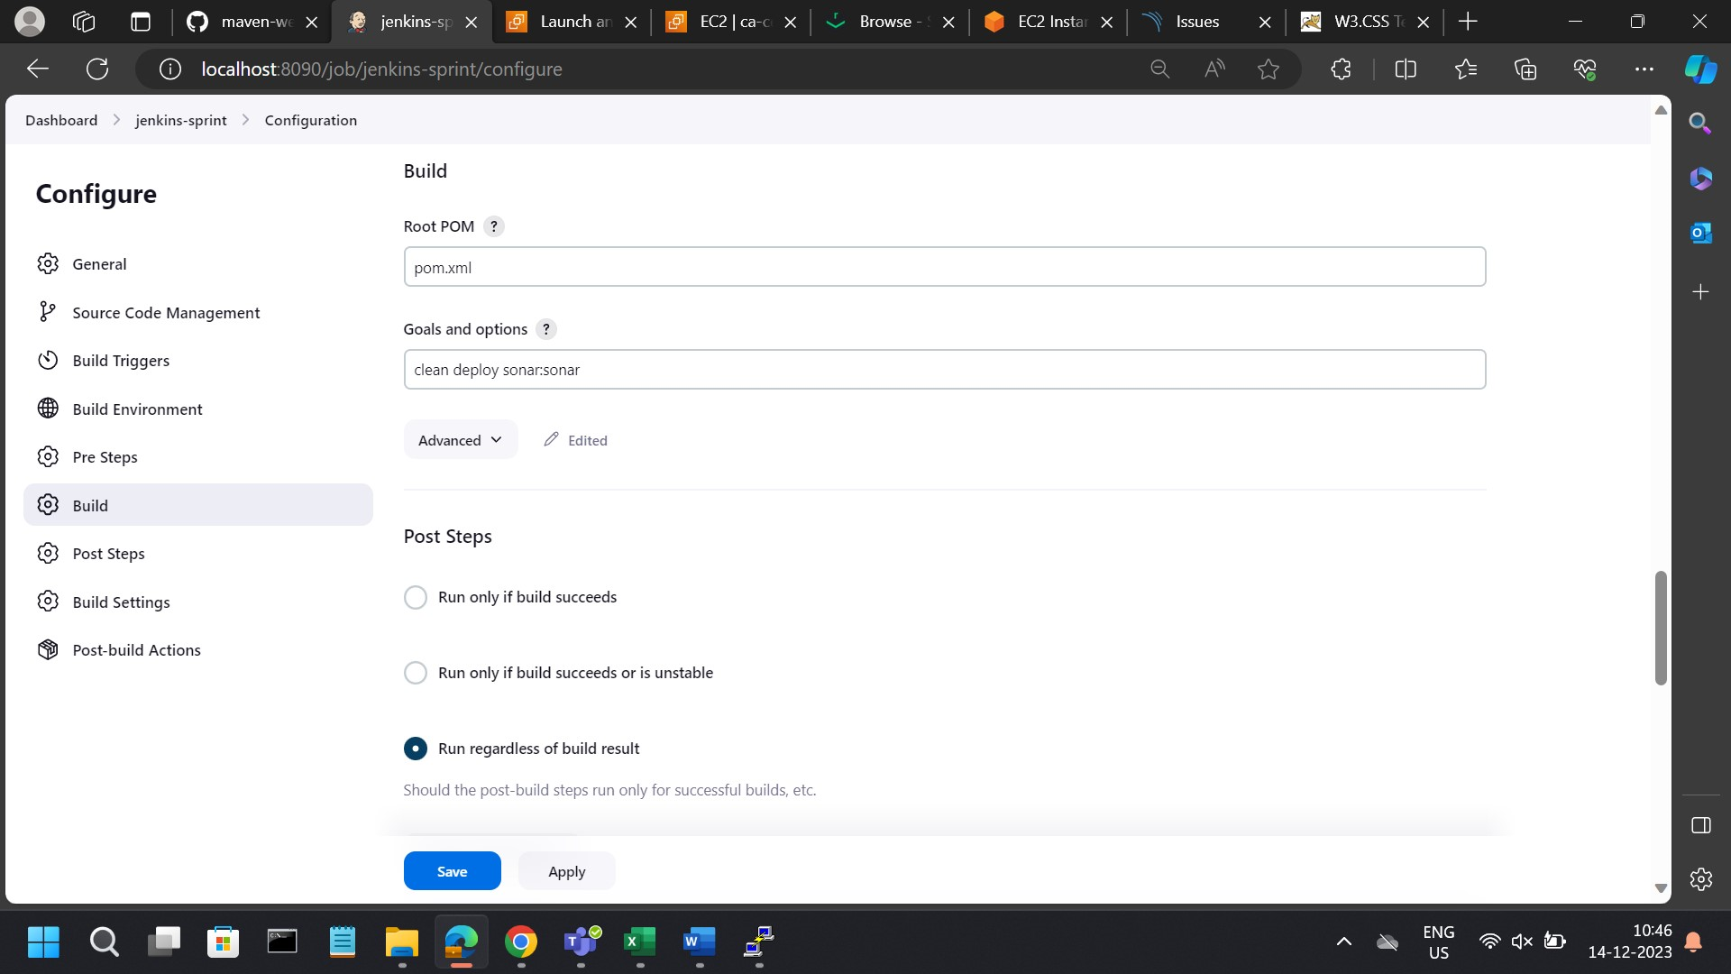

* Add these changes in settings.xml file local maven.

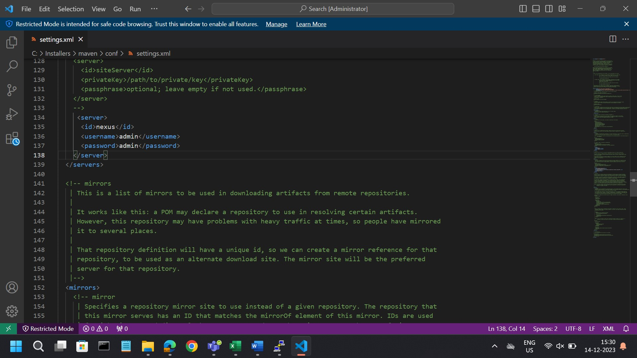

* Add local settings.xml file path to build step in Jenkins.

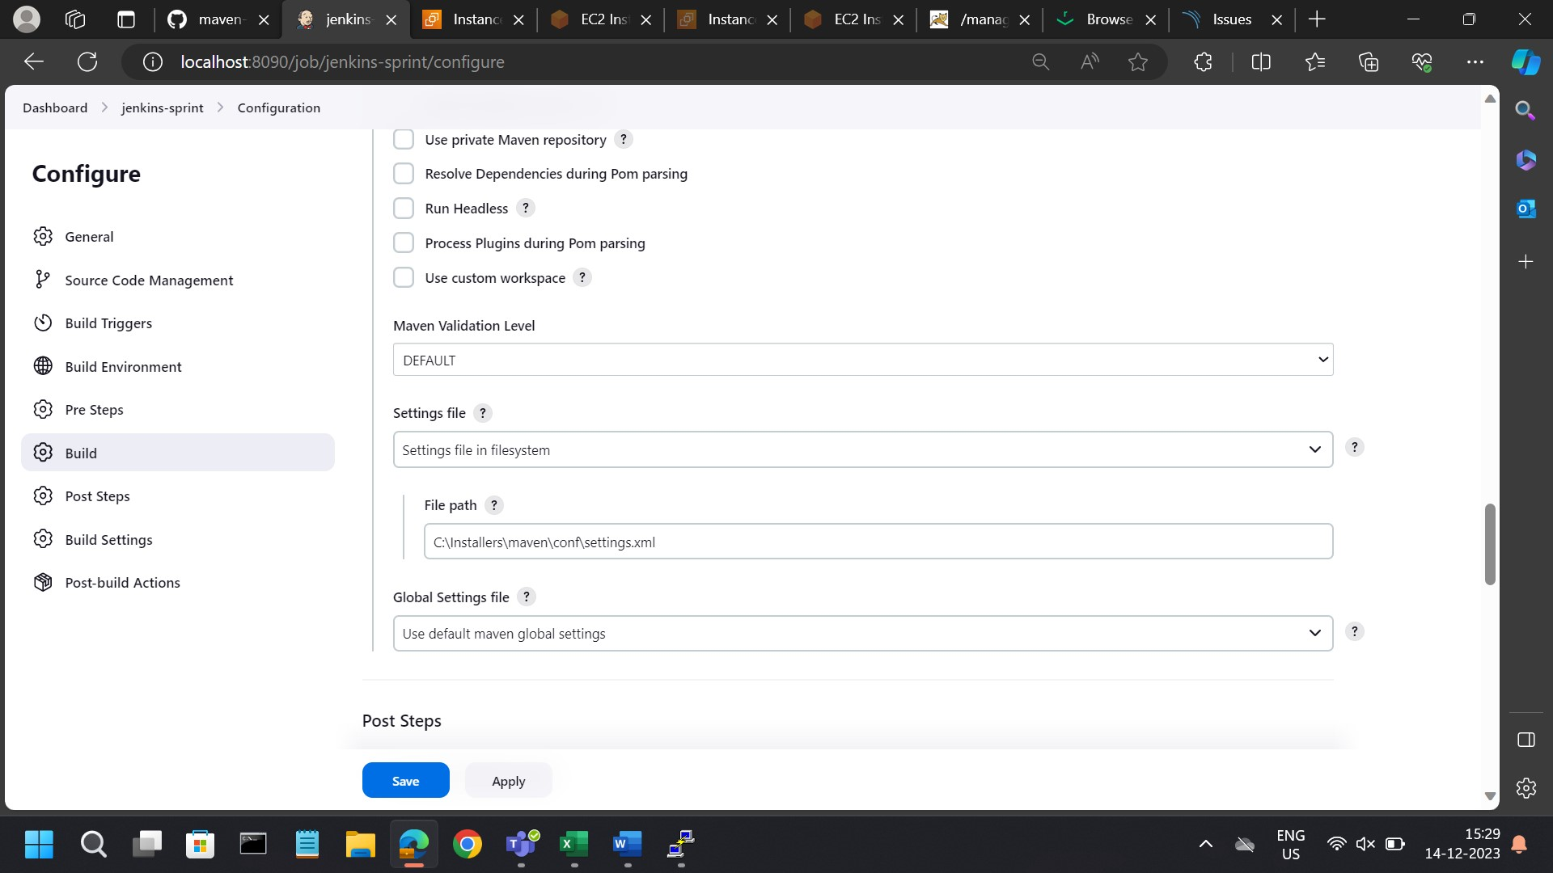

* In Post-build Actions deploy the war/ear to a container
* Add container: creation of credentials for tomcat9.x, adding a username and password.
* Pasting the URL of tomcat server.

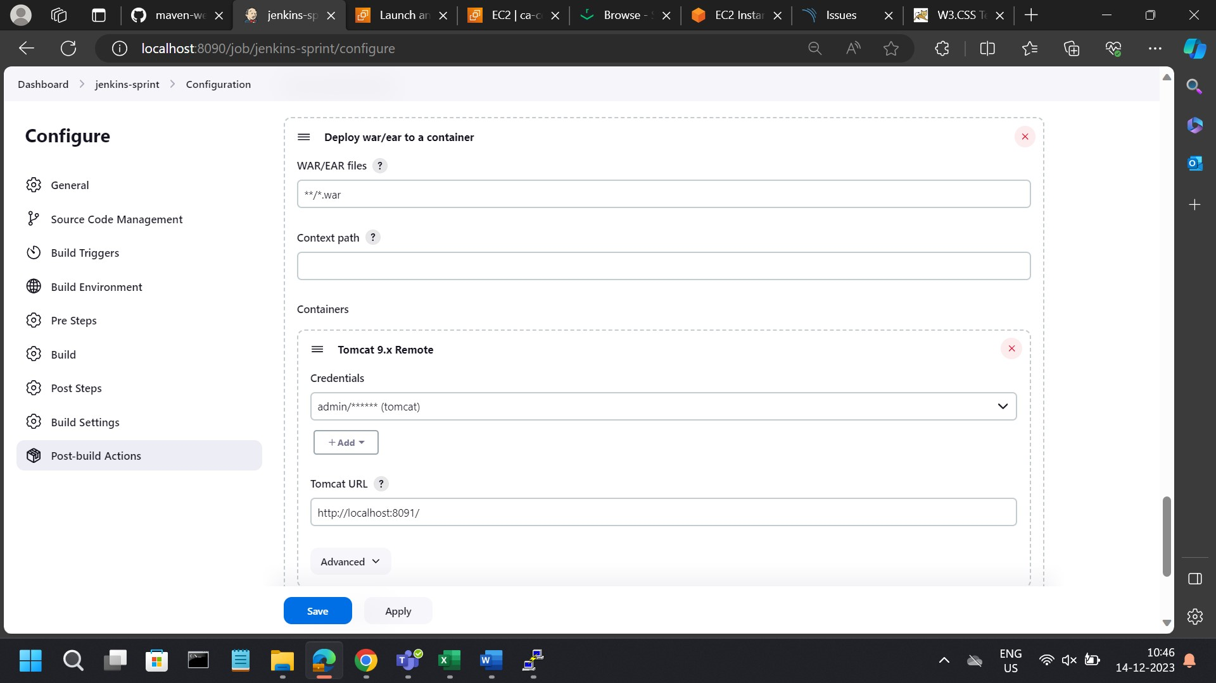

**Step-6** Click **Apply and Save** to open the Pipeline project/item view page

**Step-7** Under **Build History** on the left, click **#1** to access the details for this particular pipeline run.

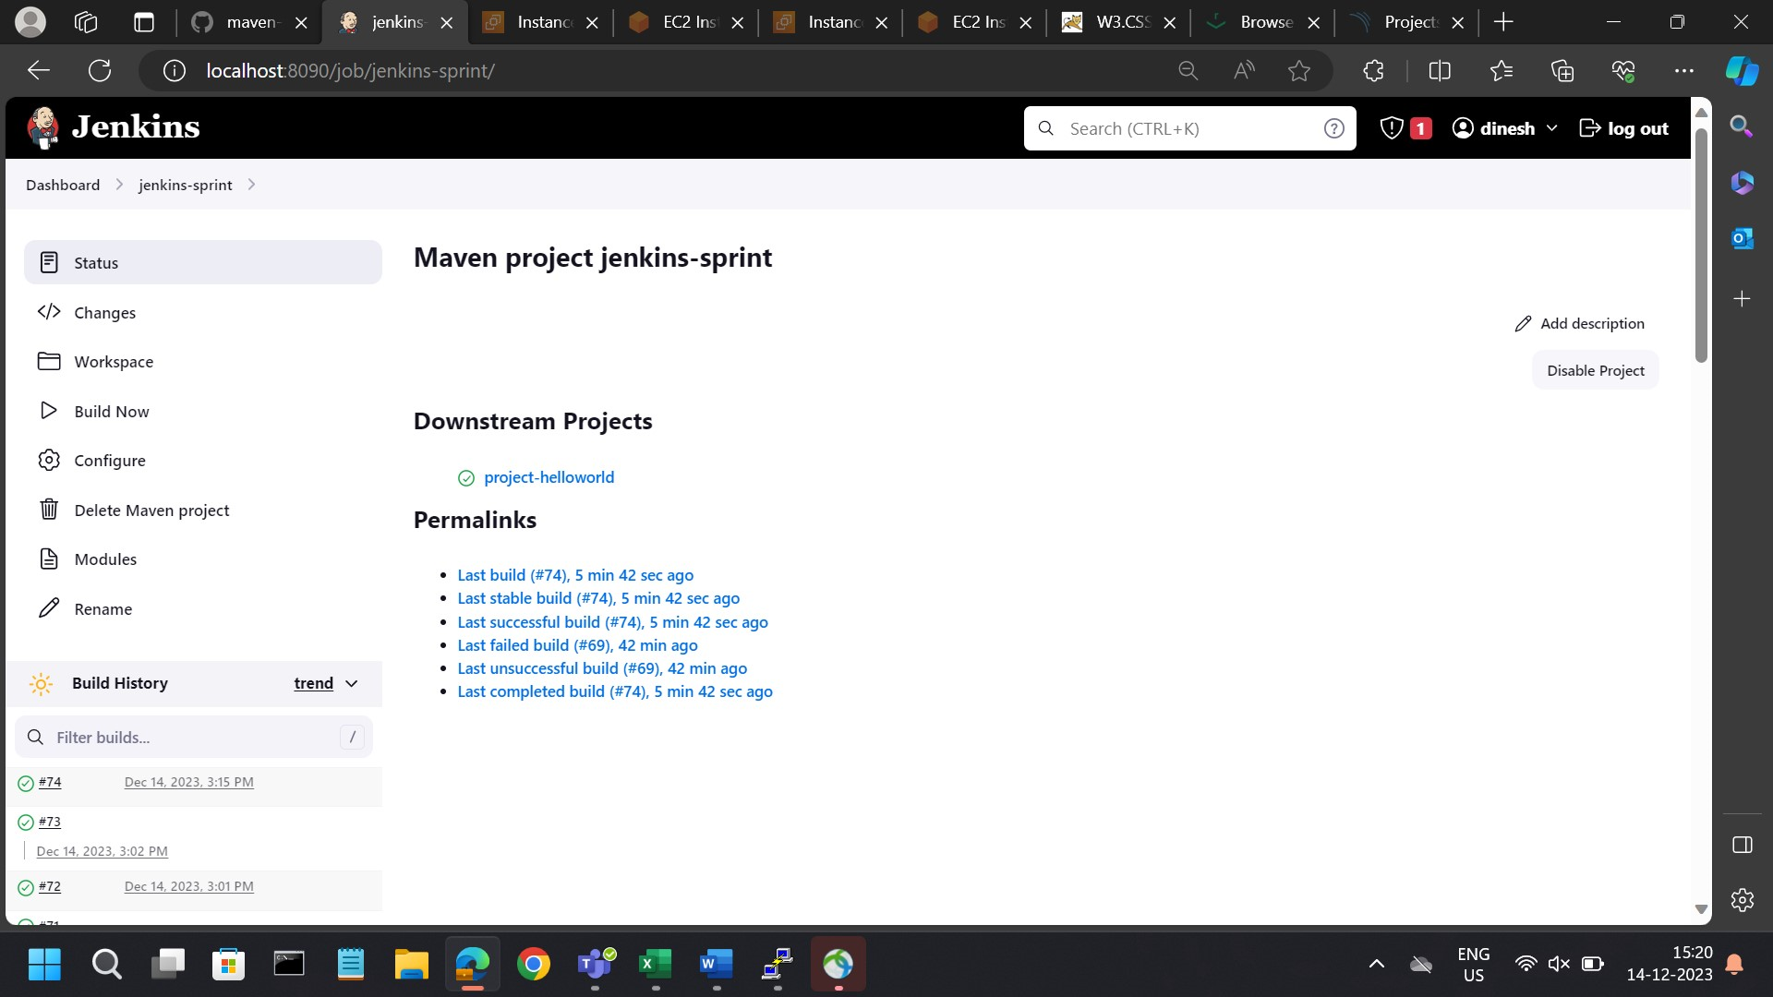

**Step-8** Click **Console Output** to see the full output from the Pipeline run. The following output shows a successful run of your Pipeline.

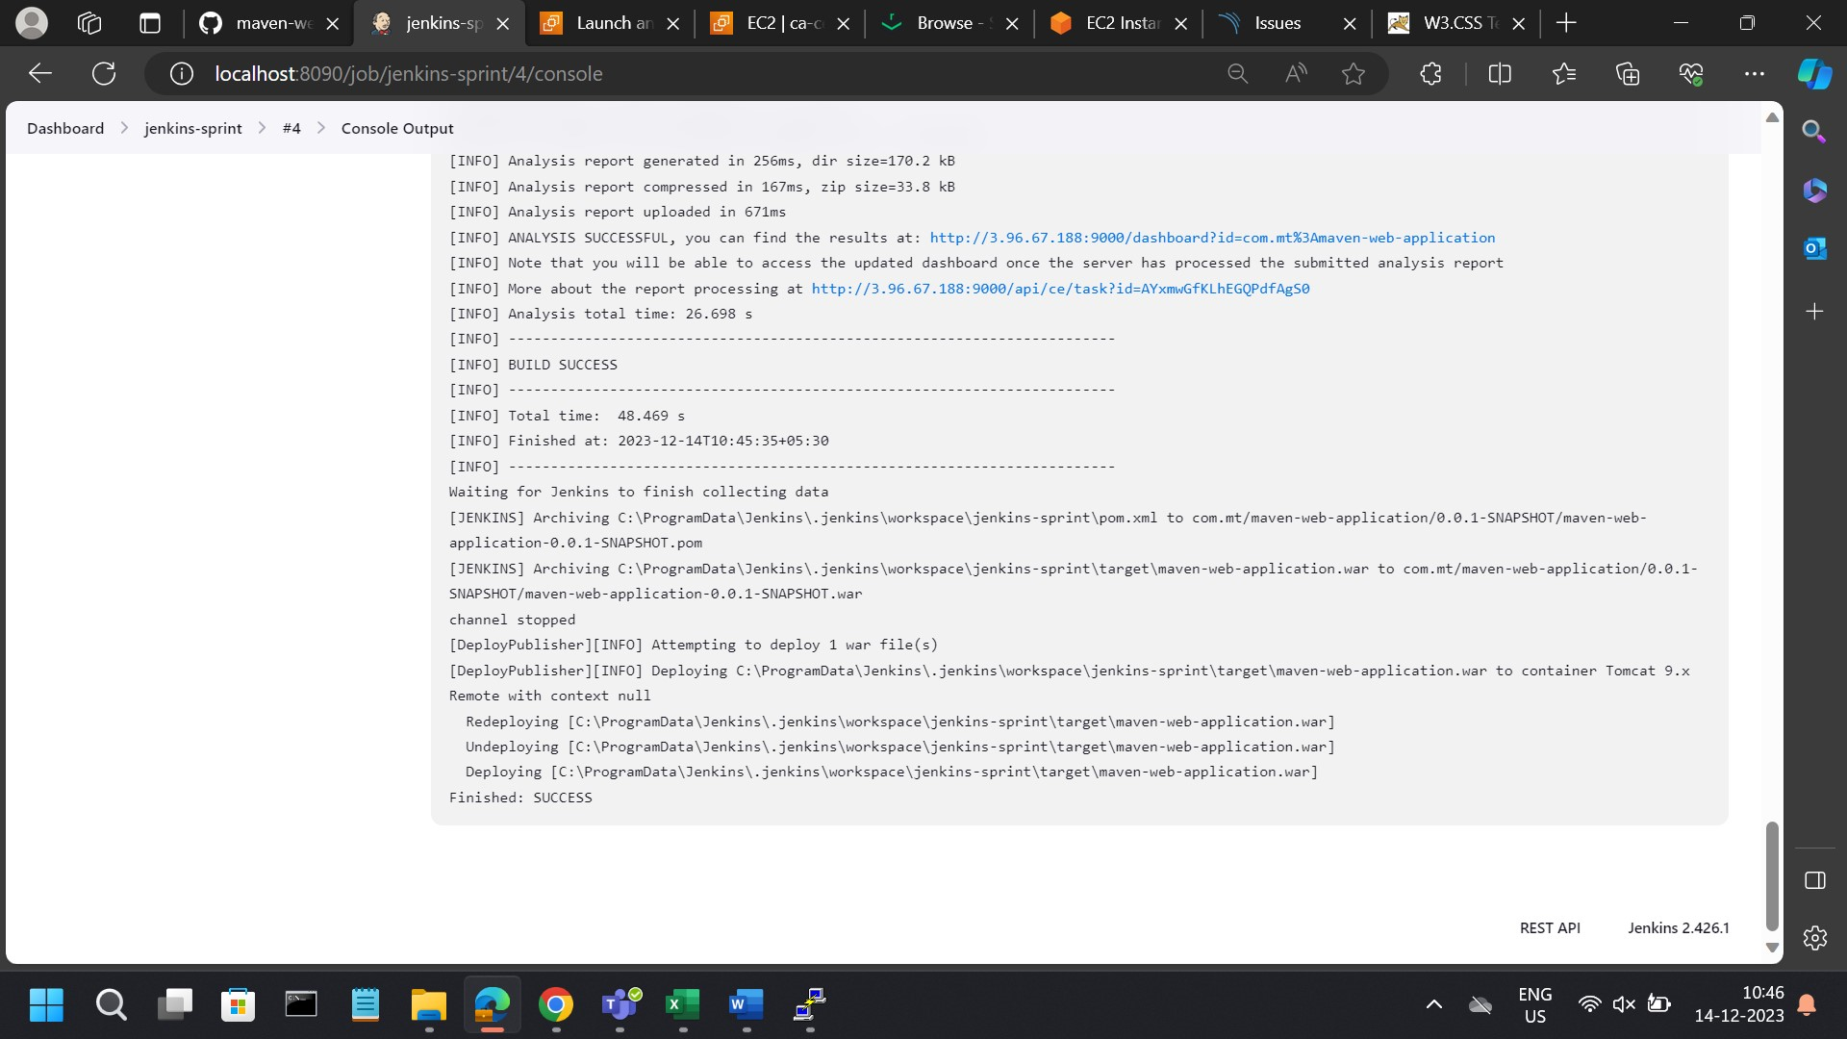

**Step-9** We can add this project to a pipeline which will automate the build process.

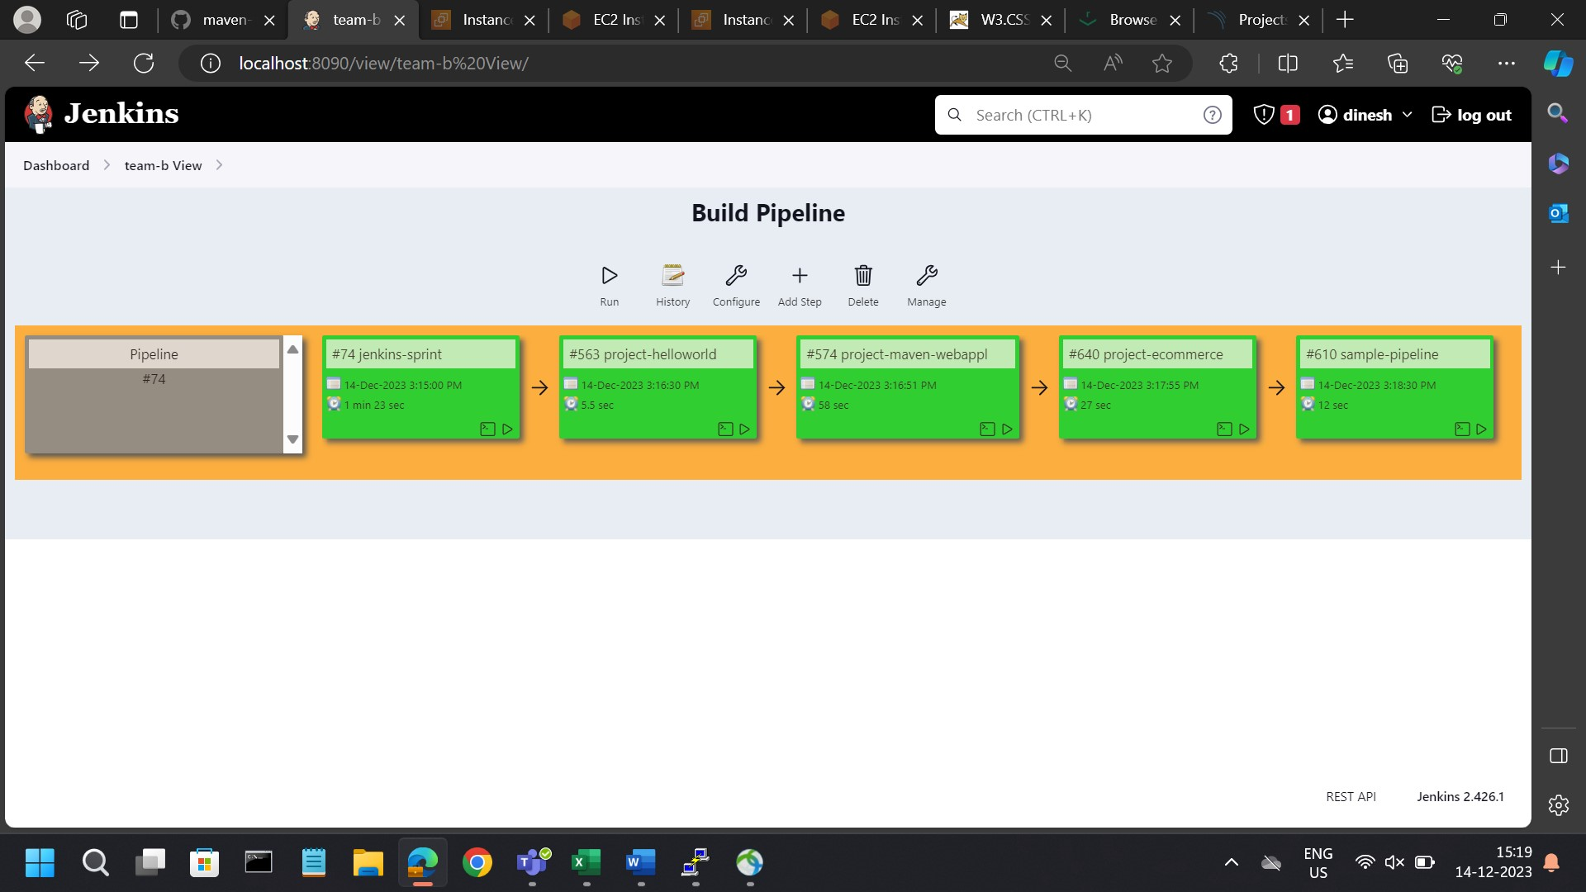

Step-10 After successful execution of our pipeline the artifact will be stored in nexus repository.

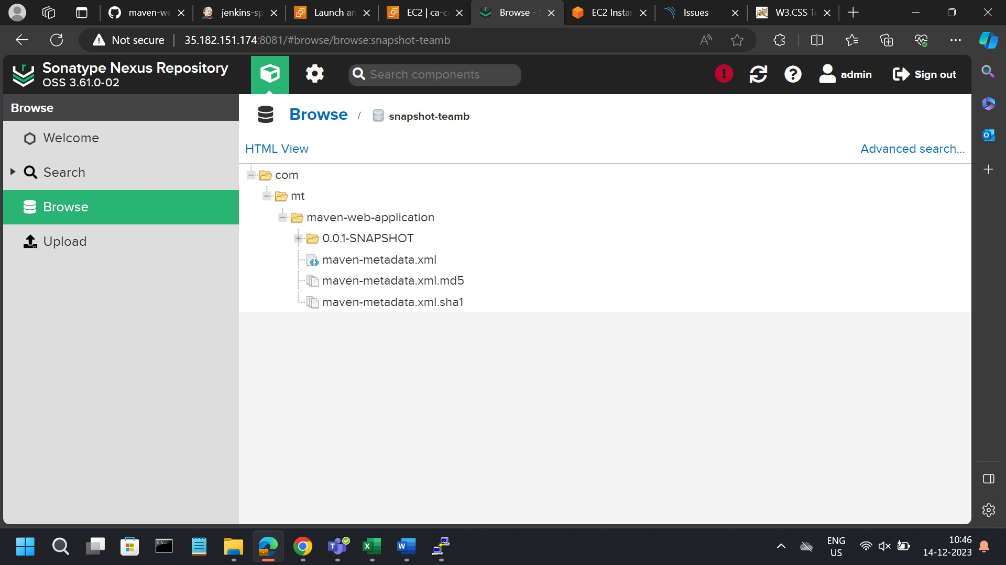

Step-11 In SonarQube server we can check the code quality of our project, we will get report of bugs, vulnerabilities and code smell.

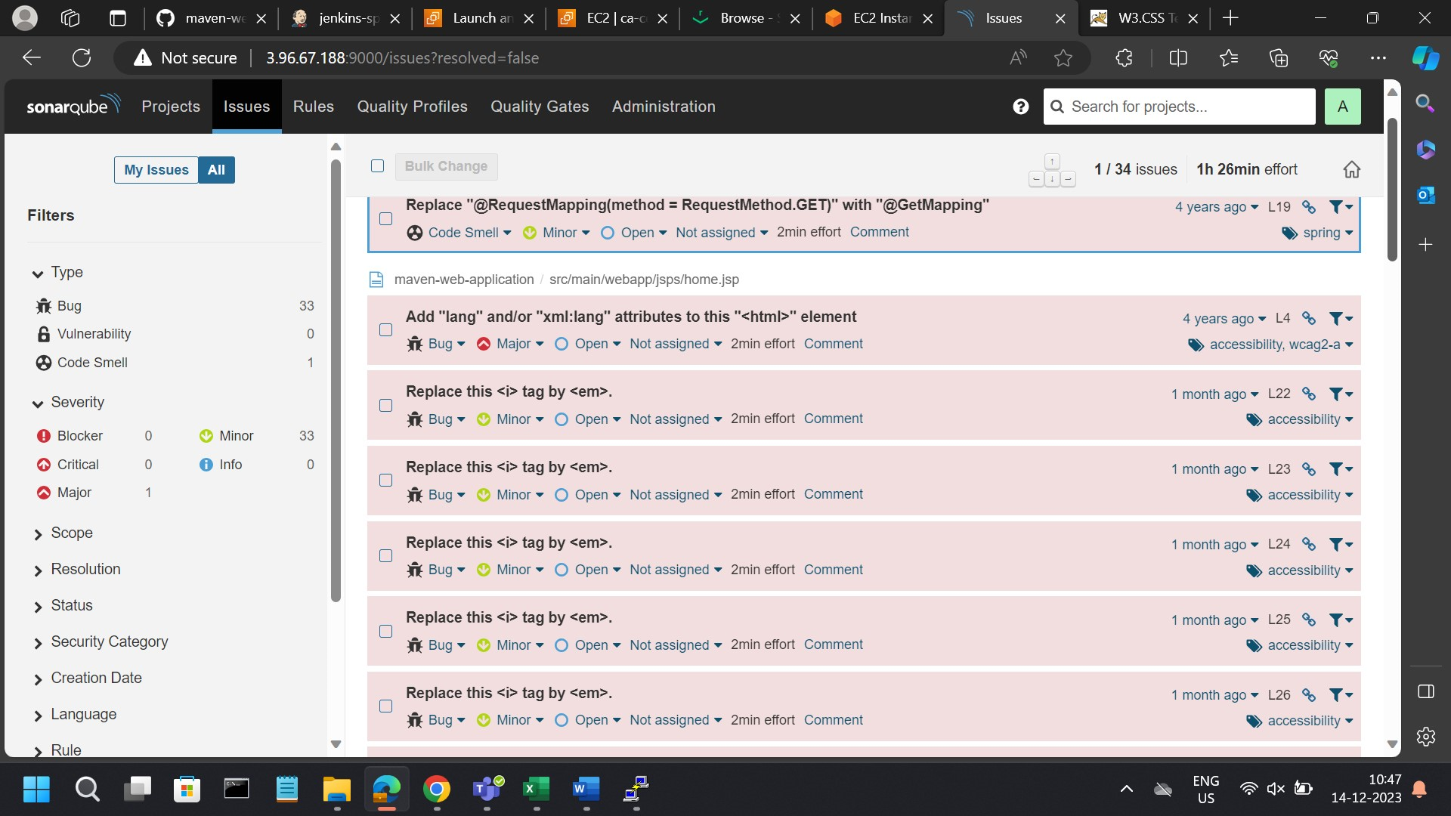

**Step-12** We can see the output of our artifact with the help of application server like apache tomcat.

